Topic :List

Exercise

Q1. Create a list of 5 random numbers and print the list

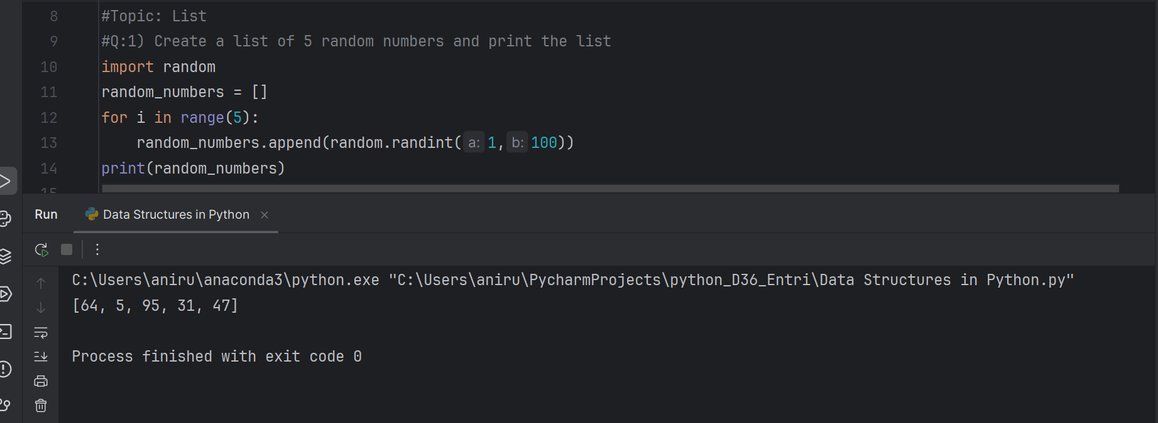

Q2. Insert 3 new values to the list and print the updated list.

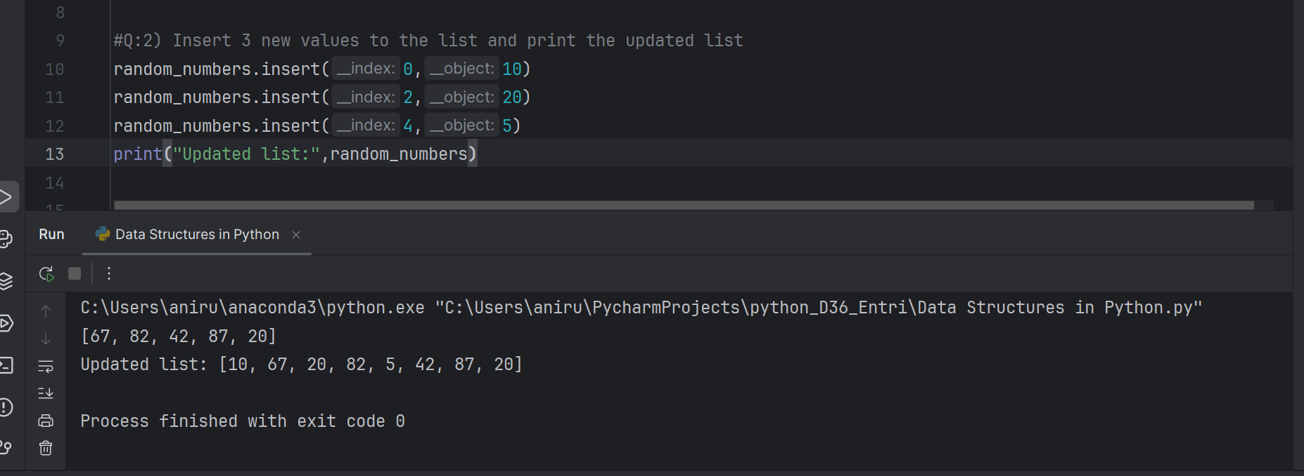

Q3. Try to use a for loop to print each element in the list.

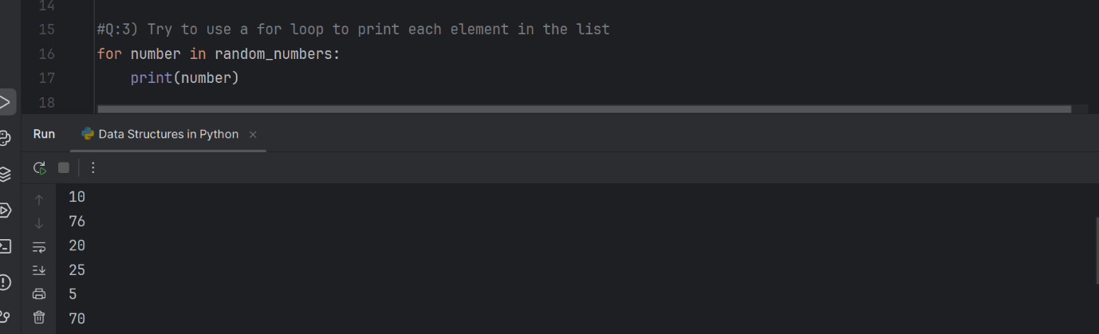

Topic: Dictionary

Exercise

Q1. Create a dictionary with keys 'name', 'age', and 'address' and values 'John', 25, and 'New York' respectively.

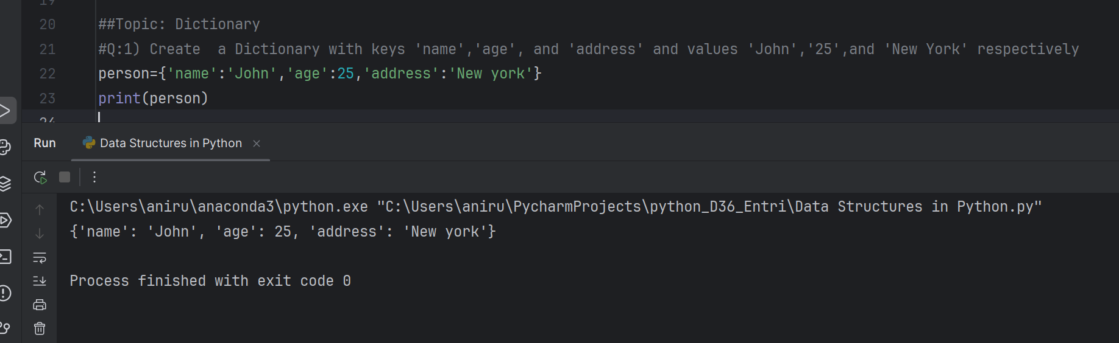

Q2. Add a new key-value pair to the dictionary created in Q1 with key 'phone' and value '1234567890'.

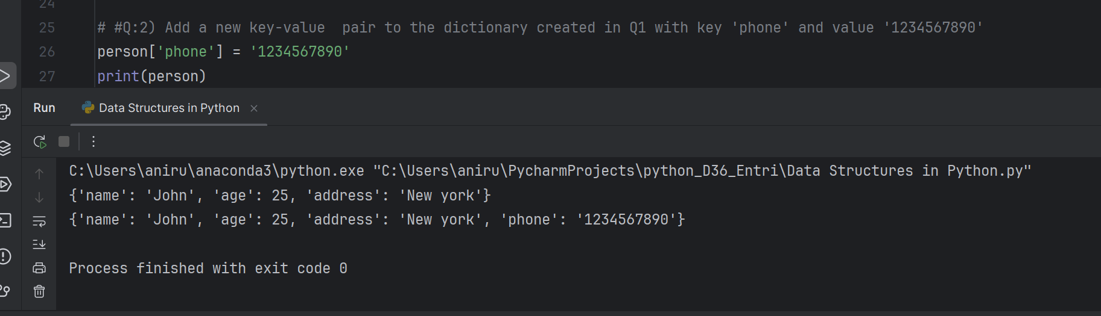

Topic: Set

Exercise

Q1.Create a set with values 1, 2, 3, 4, and 5.

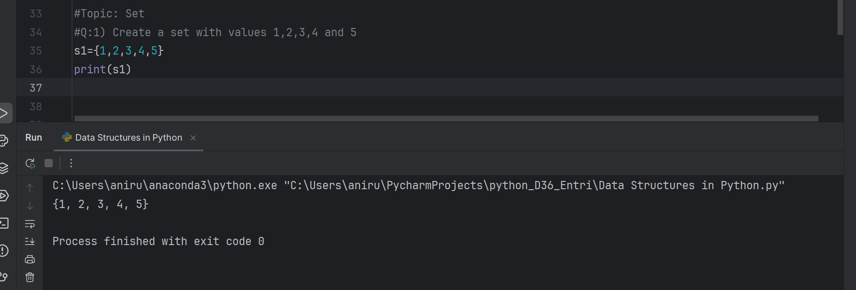

Q2. Add the value 6 to the set created in Q1.

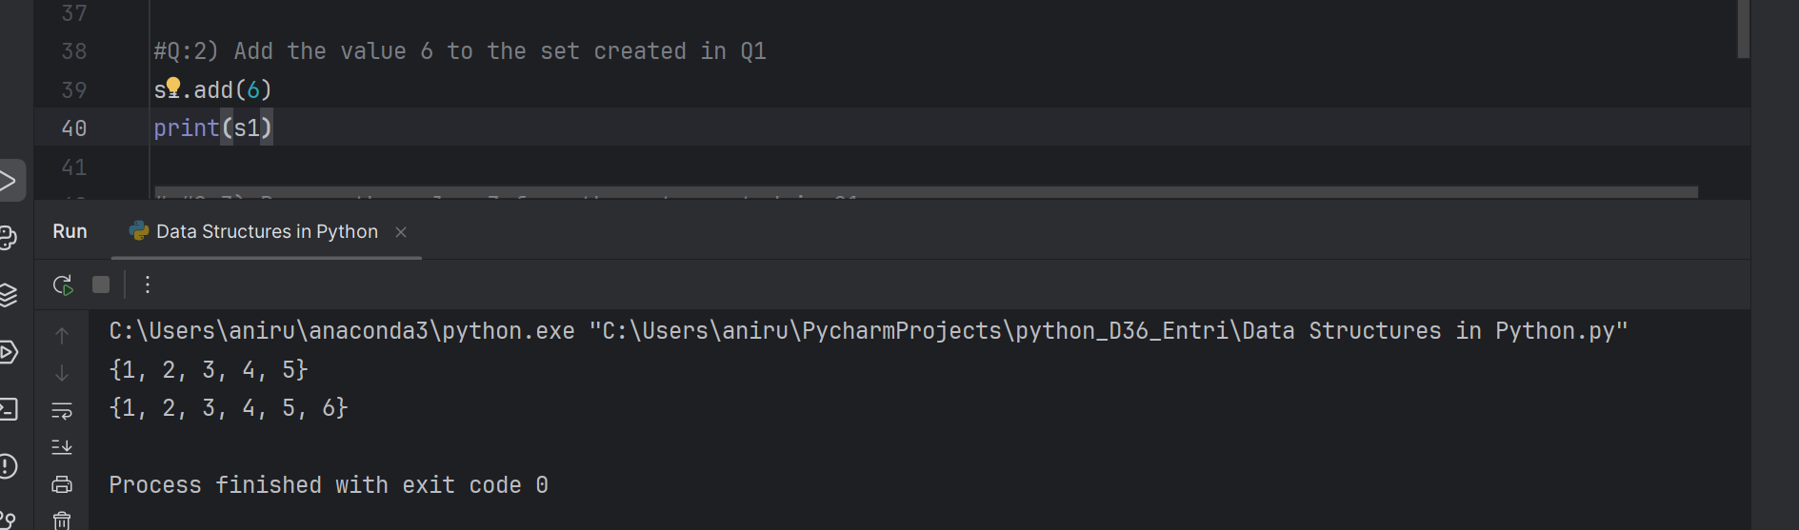 Q3. Remove the value 3 from the set created in Q1.

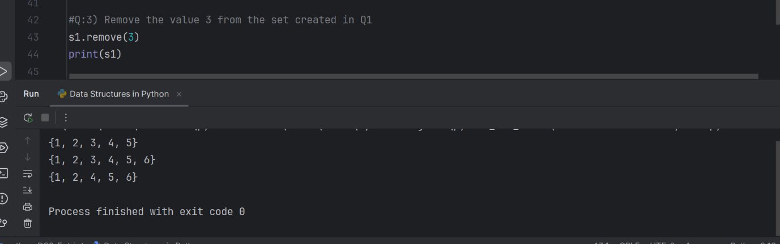

Topic: Tuple

Exercise

Q1. Create a tuple with values 1, 2, 3, and 4

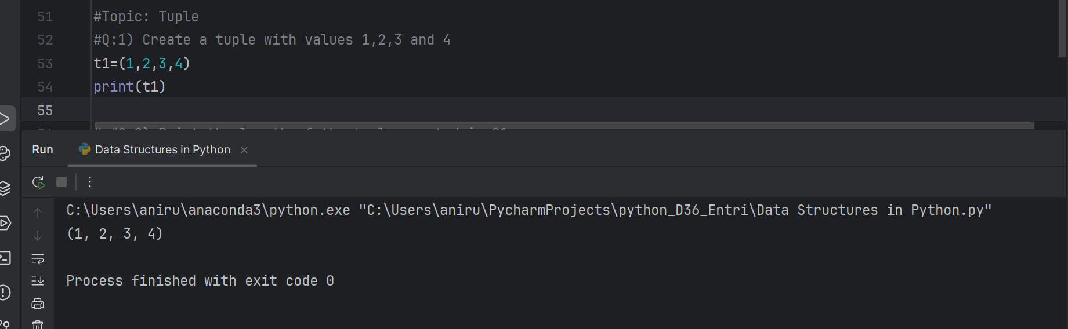

Q2. Print the length of the tuple created in Q1.

